VoltStream Documentation (Week 2)
Project Overview
VoltStream is an energy monitoring and management application created to track device usage, monitor analytics, view billing information, and manage connected devices from a single dashboard. The project combines frontend and backend technologies to create a complete full-stack application with cloud deployment support.
The application is designed in a way where users can monitor smart devices, analyze usage trends, and understand energy consumption patterns through visual dashboards and reports.

Use Case
The project can be used in homes, offices, or small businesses where multiple devices or sensors are connected to utility systems. Instead of checking different systems separately, users can monitor everything from one interface.
Users can:
- View all connected devices
- Track current usage and activity
- Analyse consumption patterns using charts
- View billing-related information
- Add or manage devices
- Understand technical terms and metrics used inside the application
The main purpose of the project is to simplify energy monitoring and make usage data easier to understand.

Project Architecture
The project follows a frontend-backend architecture.
The frontend handles everything users interact with in the browser such as pages, navigation, charts, and dashboards.
The backend handles API requests, business logic, and data processing. It sends data to the frontend whenever users interact with the application.
The overall structure looks like this:
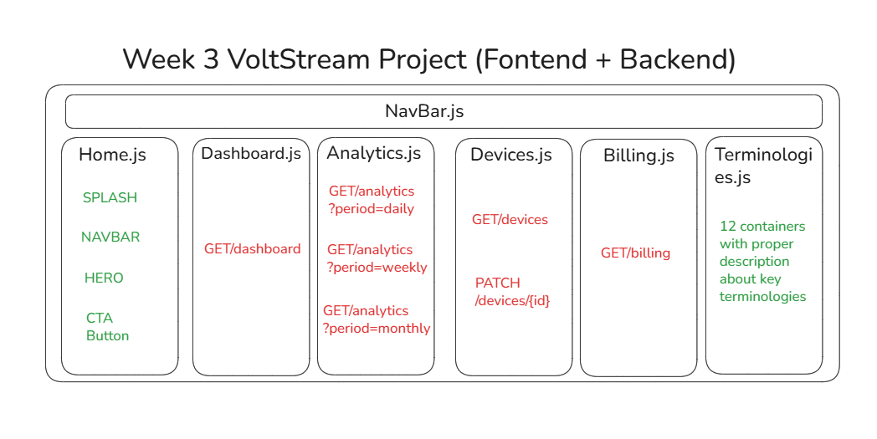
The frontend and backend work independently but communicate through API requests.

Frontend Structure
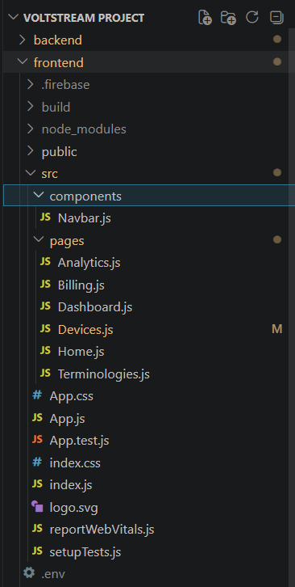
The frontend is developed using React and Tailwind CSS.
It contains different pages and reusable components that build the user interface.
Main Frontend Files
public/index.html
This is the base HTML file loaded in the browser.
src/index.js
This file starts the React application and connects React with the HTML root element.
src/App.js
This acts as the main application container. It handles routing and page rendering.
src/components/Navbar.js
This contains the navigation bar used across different pages.

Frontend Pages
Home Page
Acts as the landing page or welcome screen.
Dashboard Page
Displays overall device information, quick statistics, and summaries.
Analytics Page
Shows charts, trends, and visual analysis of energy usage.
Billing Page
Displays billing details, usage summaries, and cost-related information.
Devices Page
Allows users to manage connected devices and view device details.
Terminologies Page
Contains explanations of technical terms and application-related definitions.

Styling & Configuration
Tailwind CSS
Used for responsive styling and UI design.
package.json
Contains frontend dependencies and scripts such as:
- npm start
- npm run build
firebase.json
Used for Firebase Hosting deployment configuration.

Backend Structure
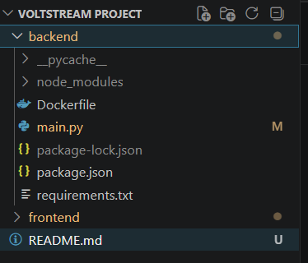
The backend is developed using Python.
It handles:
- API creation
- Request processing
- Data communication
- Backend logic
Main Backend Files
main.py
This is the core backend file where APIs and request handling logic are written.
Example functionalities include:
- Fetching device data
- Returning analytics information
- Sending billing details
- Handling user requests
requirements.txt
Contains Python dependencies required for the backend.
Dockerfile
Used to containerize the backend application for deployment.

Data Workflow
The frontend and backend communicate through APIs.
The workflow is:
- User opens the frontend application.
- React renders the required page.
- Frontend sends API requests to the backend.
- Backend processes the request.
- Backend returns data in JSON format.
- Frontend receives the response.
- UI updates dynamically with the received data.
This workflow happens continuously whenever users interact with dashboards, analytics, billing, or devices.

Local Development Workflow
Running Backend Locally
- cd backend
- pip install -r requirements.txt
- python main.py
The backend starts running on a local server.

Running Frontend Locally
- cd frontend
- npm install
- npm start
The frontend starts running in the browser using the React development server.

Deployment Workflow
Frontend Deployment
The frontend is deployed using Firebase Hosting.
Steps followed:
- Create production build using:
npm run build
- Deploy using:
firebase deploy --only hosting

Backend Deployment
The backend is deployed using Google Cloud Run.
Steps followed:
- Build Docker image
- Push image to Google Cloud
- Deploy service using Cloud Run
Example commands:
gcloud builds submit --tag gcr.io/PROJECT_ID/voltstream-backend
gcloud run deploy

Technologies Used
Frontend
- React
- Tailwind CSS
- Firebase Hosting
- Node.js
- npm
Backend
- Python
- Docker
- Google Cloud Run

Learning & Understanding
This project helped in understanding:
- React project structure
- Component-based frontend development
- Routing and navigation
- Tailwind CSS styling
- Backend API creation
- Frontend-backend communication
- Docker basics
- Firebase deployment
- Google Cloud deployment
- Production build workflows

Frontend Output:
Opening Splash Page:
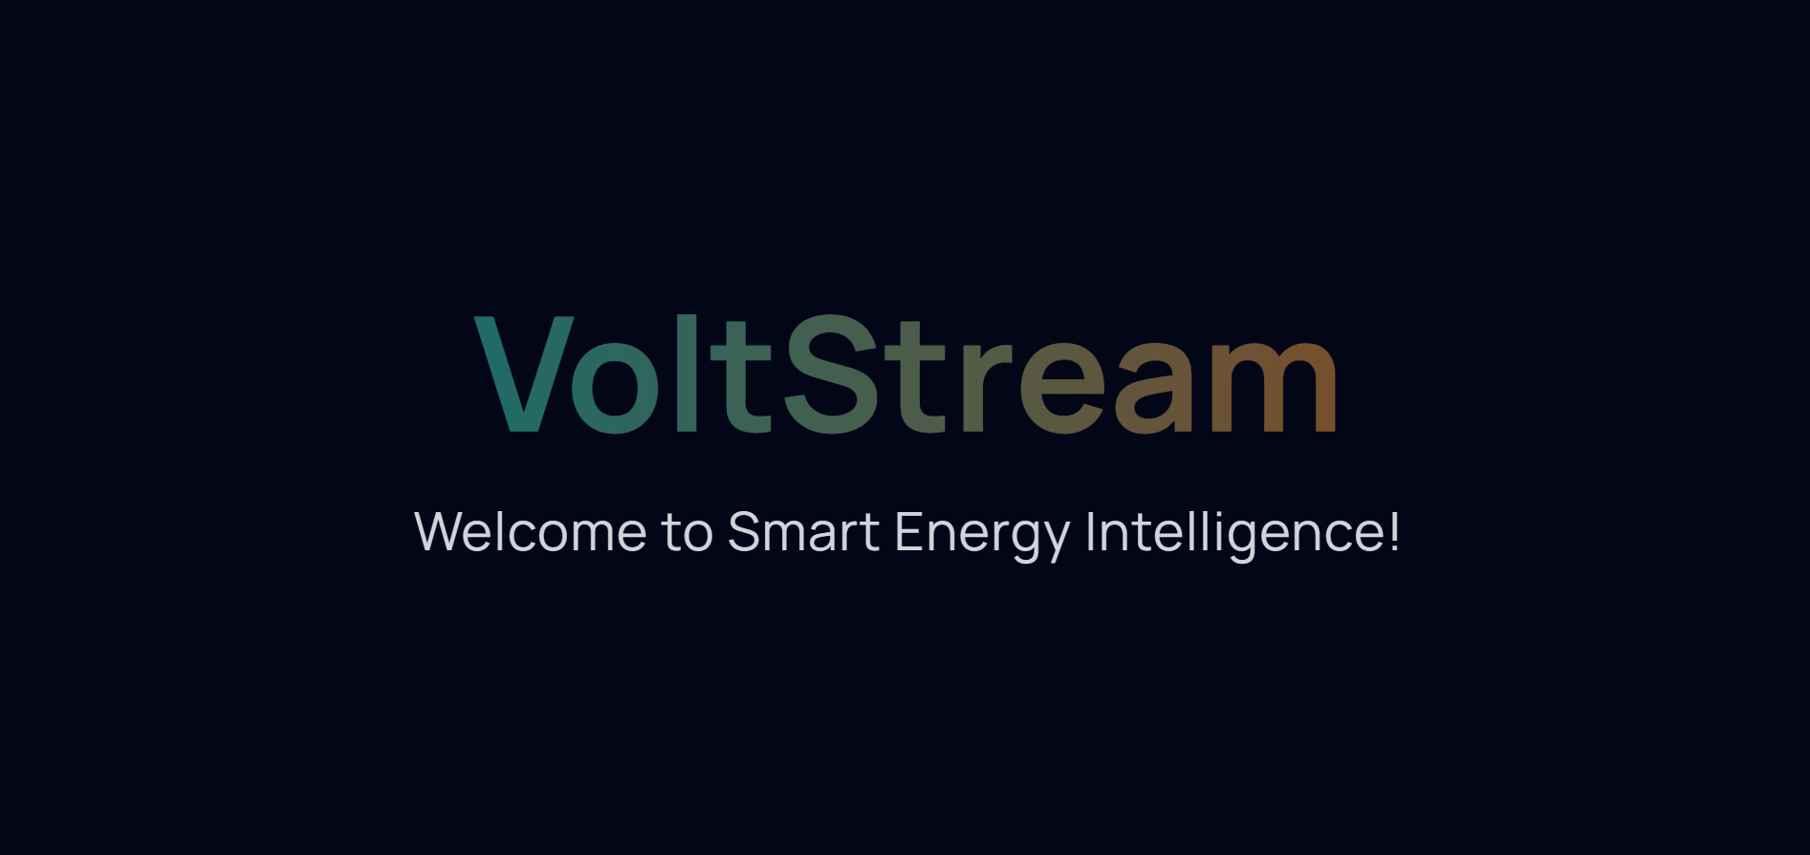

Home Page:
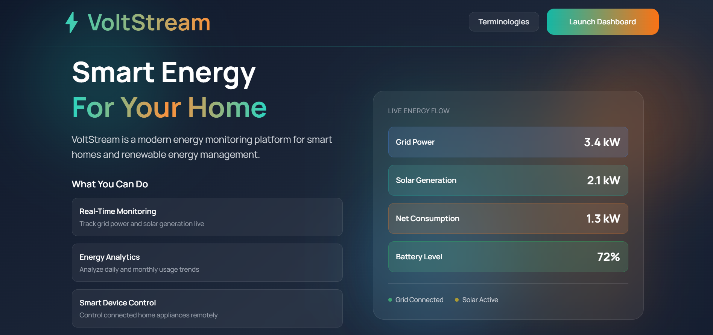

Terminologies Page:
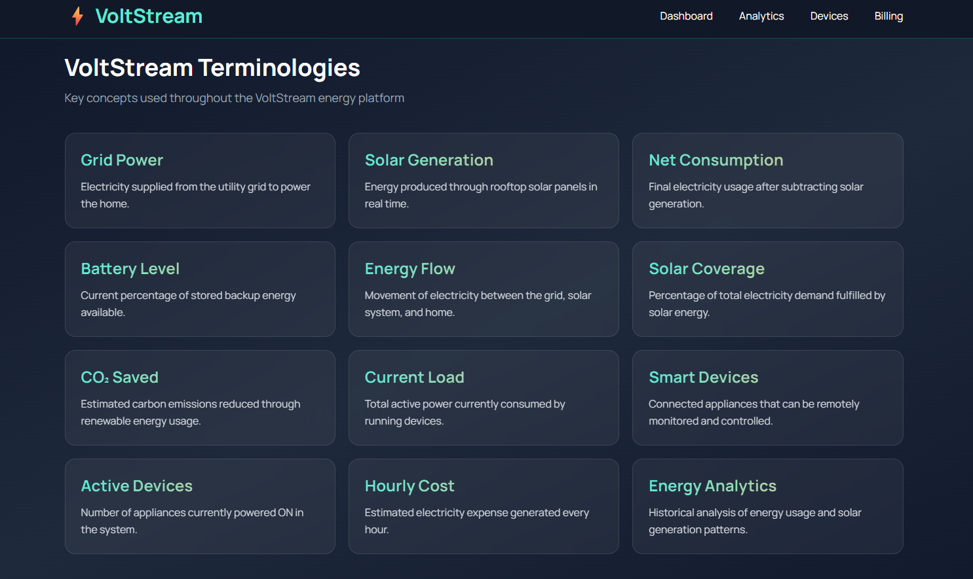

Dashboard Page:
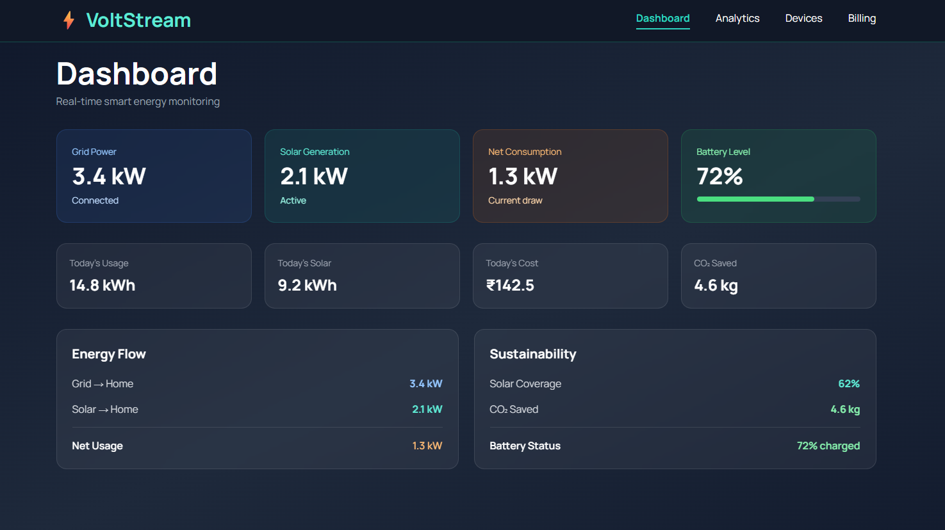

Analytics Page:
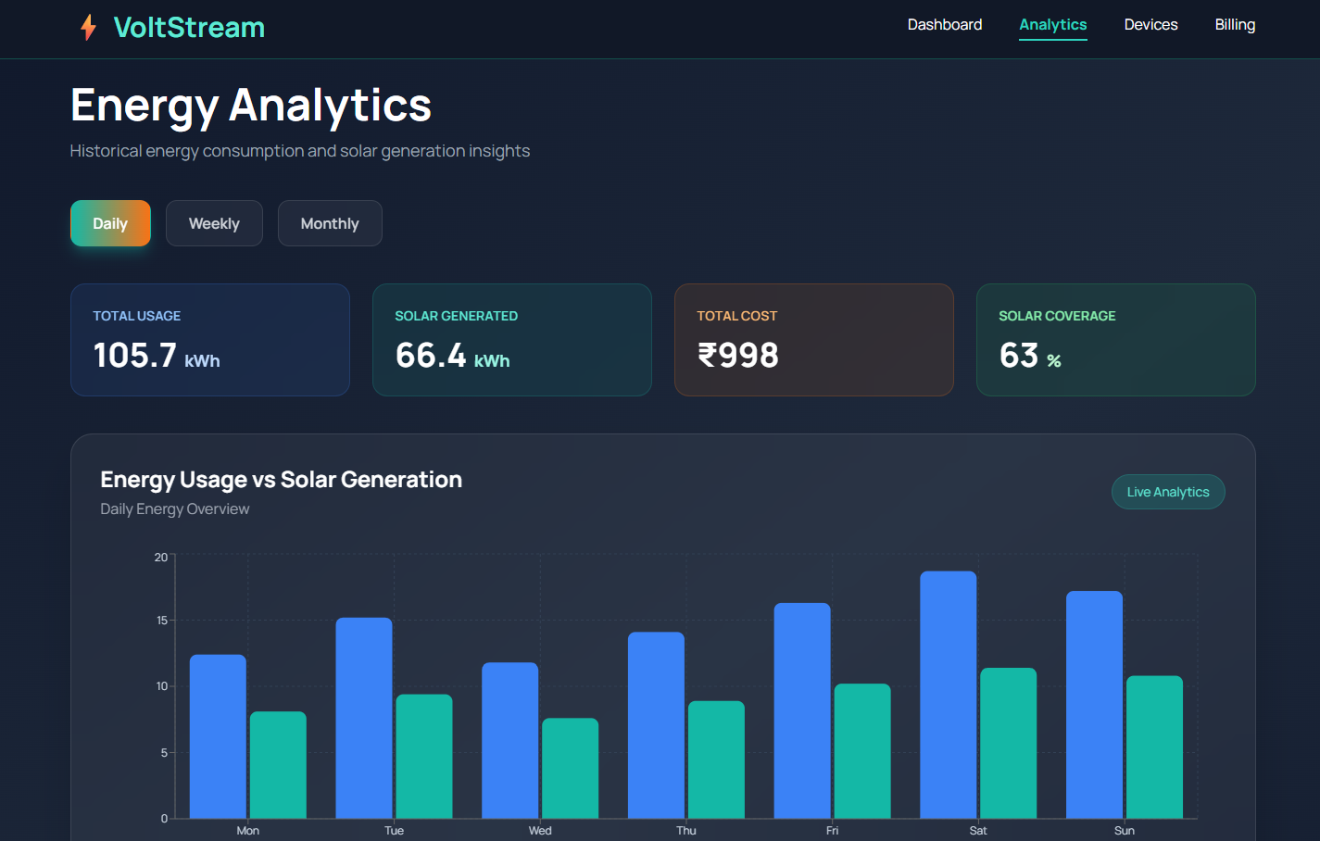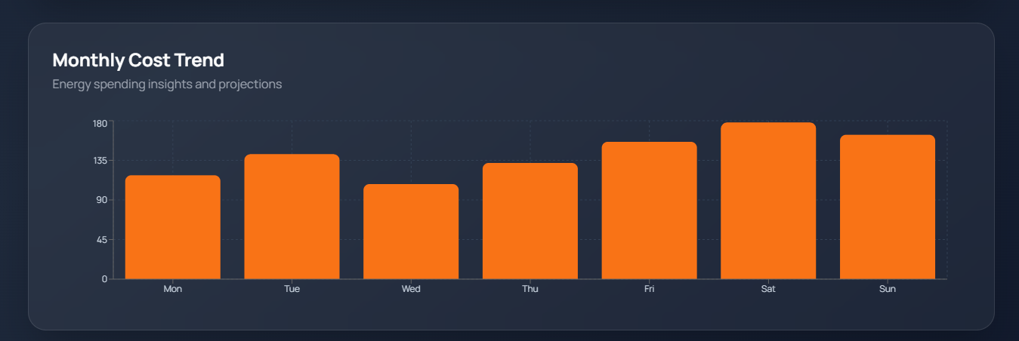

Devices Page:
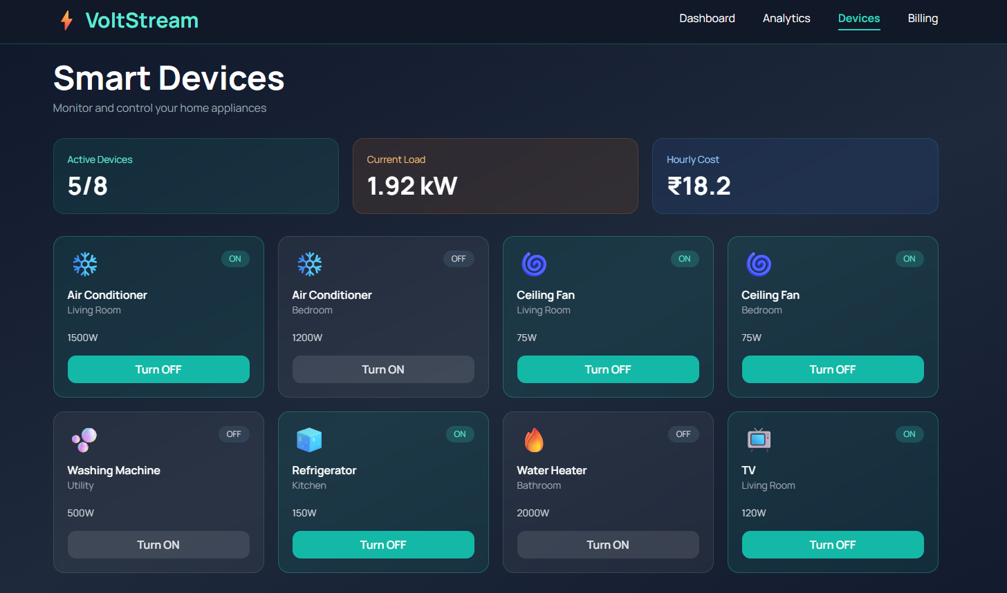

Billing Page:
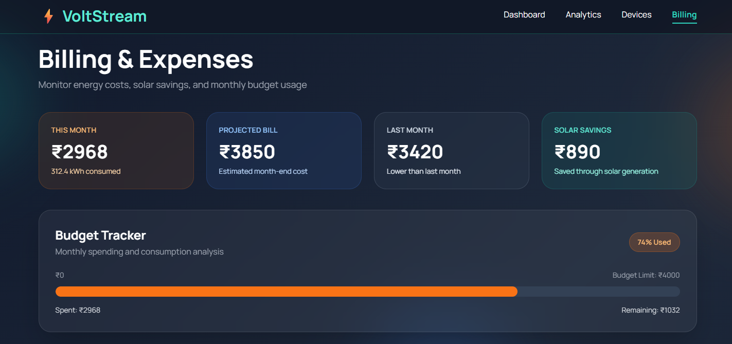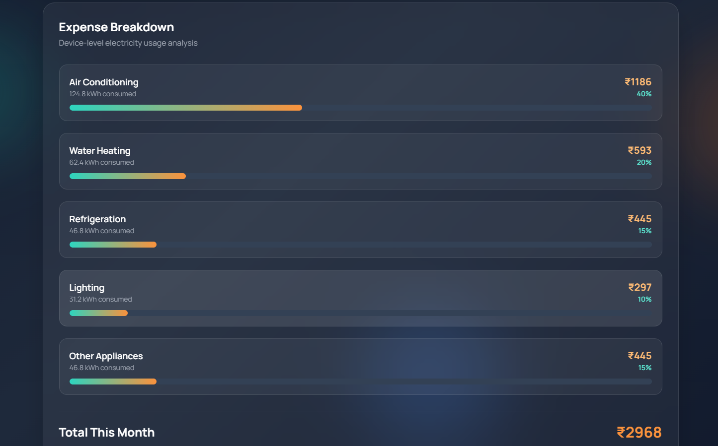

Backend Output:

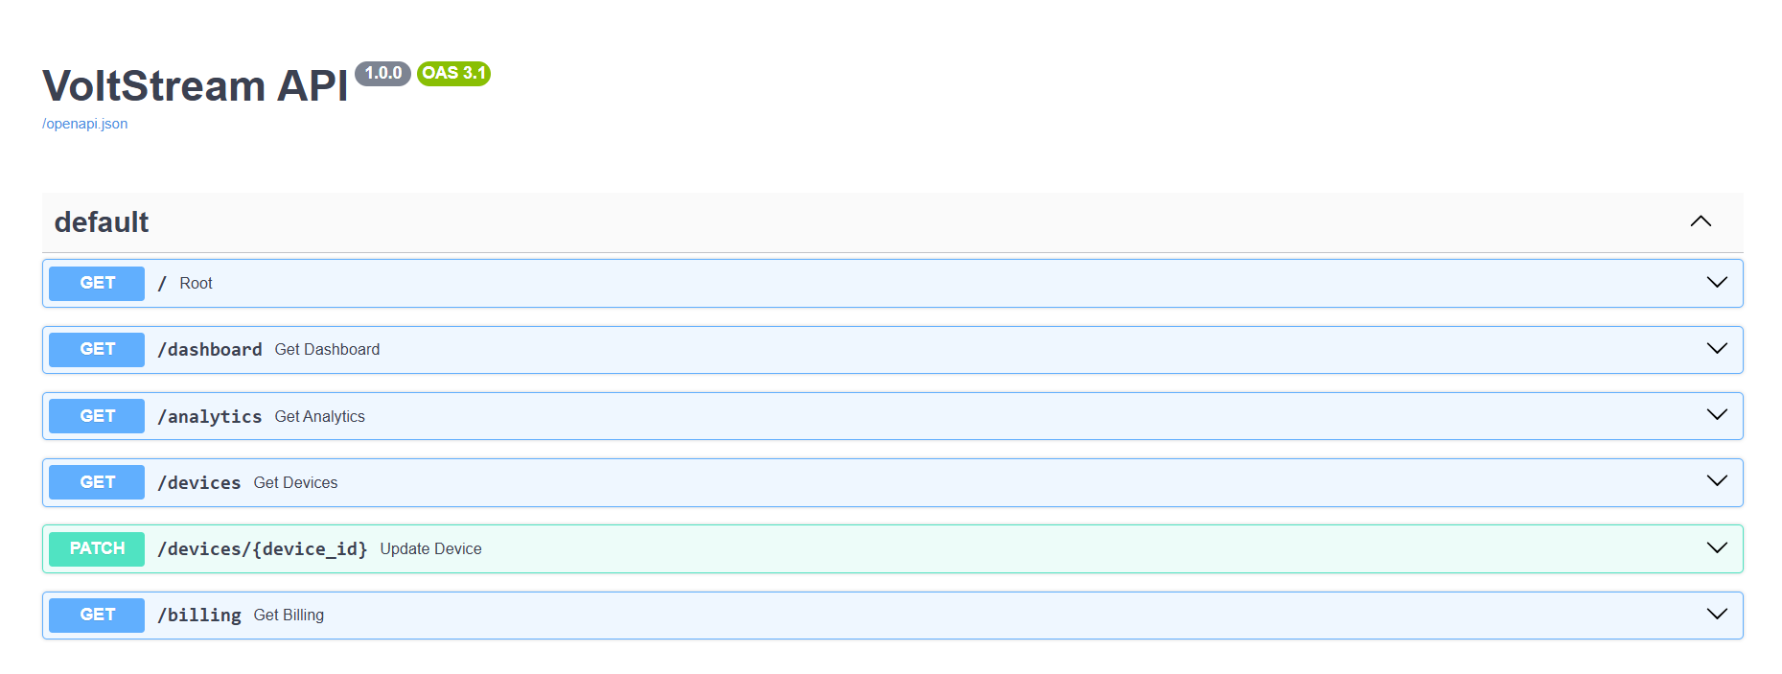

VoltStream Deployment Steps

Backend Deployment using Docker + Google Cloud Run
Step 1 – Create Backend Files
First, the backend required:
- main.py
- requirements.txt
- Dockerfile
The requirements.txt file contains Python dependencies.
The Dockerfile is used to create a Docker image for deployment.

Step 2 – Login to Google Cloud
- gcloud auth login
This opens a browser and connects the local system with the Google Cloud account.

Step 3 – Select Google Cloud Project
- gcloud config set project voltstream-yethishwar
OR
- gcloud config set project quixotic-dynamo-495704-k4
This sets the active Google Cloud project.

Step 4 – Enable Required Services
These services are needed for deployment.
- gcloud services enable run.googleapis.com
- gcloud services enable artifactregistry.googleapis.com
- gcloud services enable cloudbuild.googleapis.com

Step 5 – Build Docker Image
Move inside backend folder:
- cd backend
Build Docker image:
- docker build -t voltstream-yethishwar-backend .
This creates the backend Docker image locally.
You successfully built images like:
- voltstream-yethishwar-backend
- voltstream-backend

Step 6 – Create Artifact Registry Repository
Create repository:
- gcloud artifacts repositories create my-repo \
--repository-format=docker \
--location=us-central1
OR
- gcloud artifacts repositories create voltstream-repo \
--repository-format=docker \
--location=asia-south1
Artifact Registry stores Docker images in Google Cloud.

Step 7 – Configure Docker Authentication
Initially you got this error:
Unauthenticated request.
artifactregistry.repositories.uploadArtifacts
This happened because Docker authentication was not configured properly.
You fixed it using:
- gcloud auth configure-docker asia-south1-docker.pkg.dev
OR
- gcloud auth configure-docker us-central1-docker.pkg.dev
This connected Docker with Google Cloud authentication.
After this step, Docker push started working correctly.

Step 8 – Tag Docker Image
You tagged the local Docker image with Artifact Registry path.
Example:
- docker tag voltstream-yethishwar-backend us-central1-docker.pkg.dev/voltstream-yethishwar/my-repo/voltstream-yethishwar-backend
OR
- docker tag voltstream-backend asia-south1-docker.pkg.dev/quixotic-dynamo-495704-k4/voltstream-repo/voltstream-backend
This prepares the image for cloud upload.

Step 9 – Push Docker Image to Artifact Registry
Push image:
- docker push us-central1-docker.pkg.dev/voltstream-yethishwar/my-repo/voltstream-yethishwar-backend
OR
- docker push asia-south1-docker.pkg.dev/quixotic-dynamo-495704-k4/voltstream-repo/voltstream-backend
You successfully pushed Docker images to Artifact Registry.
Output showed:
- Pushed
- latest: digest
- image uploaded successfully

Step 10 – Deploy Backend to Cloud Run
Deploy command:
- gcloud run deploy voltstream-yethishwar-backend \
--image us-central1-docker.pkg.dev/voltstream-yethishwar/my-repo/voltstream-yethishwar-backend \
--platform managed \
--region us-central1 \
--allow-unauthenticated
OR
- gcloud run deploy voltstream-backend \
--image asia-south1-docker.pkg.dev/quixotic-dynamo-495704-k4/voltstream-repo/voltstream-backend \
--platform managed \
--region asia-south1 \
--allow-unauthenticated
Cloud Run successfully deployed the backend.
Generated service URL:
https://voltstream-backend-235566209668.asia-south1.run.app
and
https://voltstream-yethishwar-backend-536159688445.us-central1.run.app
These URLs became the live backend APIs.

Local Backend Testing
You also tested backend locally using Uvicorn.
Command used:
- python -m uvicorn main:app –reload
Backend started locally on:
http://127.0.0.1:8000
The logs showed:
- Application startup complete
- GET requests working
- Auto reload working after file changes
This confirmed backend APIs were functioning correctly before deployment.

Frontend Deployment using React + Firebase

Step 1 – Run Frontend Locally
Move to frontend folder:
- cd frontend
Run frontend:
- npm start
Frontend successfully started at:
http://localhost:3000
This was used to test and fix frontend issues before deployment.

Step 2 – Install Firebase CLI
Install Firebase tools globally:
- npm install -g firebase-tools
This installs Firebase deployment commands.

Step 3 – Login to Firebase
- firebase login
This connects Firebase CLI with Google account.

Step 4 – Initialize Firebase
- firebase init
During setup:
- Hosting option selected
- Build folder selected
- React SPA configuration enabled

Step 5 – Configure Build Directory
While running Firebase initialization:
- Set public directory as:
- build
This tells Firebase to deploy React production files.

Step 6 – Create Production Build
Run:
- npm run build
This creates optimized production files inside:
frontend/build
The build folder contains:
- Optimized HTML
- CSS
- JavaScript bundles

Step 7 – Deploy Frontend
Deploy command:
- firebase deploy
OR
firebase deploy –only hosting
Firebase uploads the React build files and provides a live frontend URL.

Complete Workflow Followed
The overall deployment workflow became:
- Create backend APIs
- Create Dockerfile and requirements
- Build Docker image
- Configure Google Cloud
- Push image to Artifact Registry
- Deploy backend using Cloud Run
- Test backend locally and on cloud
- Build React frontend
- Configure Firebase Hosting
- Generate production build
- Deploy frontend using Firebase
- Connect frontend with deployed backend API

Hosting URL’s
Backend: https://voltstream-yethishwar-backend-536159688445.us-central1.run.app
Frontend: https://yethishwar-voltstream.web.app/

